**KMTC**

**Communication skills**

**Lecturer:**

Muchuka Nahason,

Msc. AHN, UoN.

nahasonho@gmail.com

072914885

**Module outcomes**

At the end of this unit the learner should be able to:

1. Explain the importance of effective communication
2. Explain the concept of communication
3. State methods of communication
4. Communicate effectively
5. Explain barriers to communication

**Course outline**

**Introduction to communication**

**Communication**

– Theories, models, stages, processes and importance of communication

* One way, two way communication
* Advantages and disadvantages of one way, two communications
* Effective communication
* Characteristics, advantages and barrier of effective communication
* How to overcome communication barriers

**Mode of communication**

* Intrapersonal, interpersonal and mass communication
* Kinds of communication – oral, written, non-verbal, interview, public speaking, elements of non-verbal communication and importance of non-verbal

Listening skills

* Steps of listening skills
* Levels of listening skills
* Barrier to effective listening skills
* Ways of improving listening skills

**Pattern of communication**

* Patterns
* direction of communication
* strategies to improving communication

**Reading and writing skills**

* Reading techniques
* Presentation soft skills training

**Definitions of terms**

Communication

* Is giving, receiving or exchange of information, opinions or ideas by writing, through speech, through visual means or any combination of the three so that the materials communicated is completely understood by everyone concern.
* Is process of transferring information from one source to another.

Medium

Is the larger group of ways of communicating within which the particular communication will be classified. There are 3 types of media

* Written communication- letters, magazines, newspaper etc.
* Oral communication – any method using the spoken words
* Visual communication eg. drawing, photographs, Posta’s and any other form of putting a message in a pictorial form.

Channel

Is a physical mean by which a message is conveyed. The different type of communication may have different channel for transmission of information.

Eg.

* In written the channel might be noticeboard, postal services
* In oral communication may be personal interview, meeting or telephone system.
* For visual communication – television, computers

**Theories of Communication**

Study of communication and mass media has led to formulation of many theories

1. **Authoritarian Theory**

According to this theory, mass media though not under the direct control of the state, it had to follow its bidding. Under an authoritarian approach in Western Europe, freedom of thought was jealously guarded by a few people. Steps were undertaken to control the freedom of expression and the result was advocacy of complete dictatorship

1. **Free Press Theory/Libertarianism**

This theory is based on the right of an individual and advocates the absence of restraints. The basis of this theory states back to the 17th century in England when the printing press made it possible to print several copies of a book or pamphlet at cheap rates. The state was not a major source of interference on the rights of an individual and his property. Liberations regarded taxation as institutional theft.

1. **Social Responsibility Theory**

According to the theorists who supported this theory, stated that pure ‘libertarianism’ is outdated and absolute. They advocated for the need of its replacement by the social responsibility theory. The commission found that the free market approach to press freedom had only increased the power of a single class and has not served the interest of the less well off classes. The emergence of radio, TV and film suggested the need for some means of accountability. Thus the theory advanced some obligations on the part of the media to society.

1. **Communists Theory**

In this theory it was thought that the entire mass media was saturated with bogus ideology. According to the theories, they believed that the ideas of the ruling classes are the ruling ideas. The freedom of press and the modern technological means of information must be controlled for enjoying effective freedom of press. The theory advocated that the sole purpose of mass media was to educate the great masses of workers and not to give information

1. **Development Communication Theory**

The underline fact behind the genesis of this theory was that there can be no development without communication. Under this theory, the media undertook the role of carrying out positive developmental programs accepting restrictions and instructions from the state. The media subordinated themselves to political, economic, social and cultural needs.

There more theories you can read e.g. agenda setting, social learning, act network theory, social exchange theory etc.

**Models of Communication**

The purpose of a “model” is to offer a visual representation of a concept with the intent of facilitating its understanding.

Models of communication refers to the conceptual model used to explain the human communication process. The first major model for communication came in 1949 by Shannon and Warren Weaver.

**The Shannon Weaver Model of Communication Theory**

When you think about communication issues in the field of health and social care, it is helpful to break down the different components of the communication process. This way, you can think about all the different steps that take place in every interaction between you and a service-user or colleague, and about all the possible barriers or difficulties that might lead to a breakdown in communication.

There are many models and theories that analyse the communication process. the best-known one is: The Shannon-Weaver model. This model was first published in 1948, and it has been adapted, modified, and developed in many ways since. Claude Shannon was a mathematician and Warren Weaver was a scientist. They were primarily interested in “machine translation”, and how early computers, radios and televisions transmit information. However, the theory equally applies to human communication, and it remains hugely influential in modern social sciences.

It is the foundation of most current communication theories, and for this reason, it is sometimes referred to as “the mother of all models”.

The Shannon-Weaver model introduces 5 key stages to the communication process:

• The sender

• The encoder

• The channel

• The decoder

• The receiver

The sender is the person, group or organisation that first thinks of the message that they want to communicate.

The encoder takes this message and turns it into signals. In other words, this is the language we use to express our thoughts. It could be written or spoken, or equally could be through signing or body language. Even using gifts and emoji’s is a form of encoding!

The channel refers to how the message is sent. This could be sound through the airwaves in a spoken conversation, or binary data transmitted electronically in an email or text. Of course, depending on the channel, the sender and receiver may need equipment such as phones or computers. When the message arrives, it must be decoded. This stage describes how the receiver interprets the message and converts it to language. Again, this could be a machine that does this electronically using binary data, or it could be our brains, when we pick up on all the language and communication data, including words, visuals and so on that form a communication transaction.

The receiver has the message, interpreted by their brain into something meaningful. Of course, we all know that the process is not always that simple, and there are often obstacles to communication. Therefore, the Shannon-Weaver model introduces the concept of “noise”.

Noise refers to anything which interferes in the channel stage of the model. This could literally be background noise which makes it hard for a receiver to hear a message, or it could be distractions which prevent them from focusing on the communication. If you imagine you are talking to a service user who is in a great deal or physical pain, or perhaps stress or emotional anguish, then all those feelings would constitute noise, which would limit their ability to focus on, and interpret the message.

Advantages of Shannon model

* Concept of noise helps in making the communication effective by removing the noise or problem causing noise.
* This model takes communication as a two way process. It makes the model applicable in general communication.
* Communication is taken as quantifiable in Shannon Weaver model.

**DERIVATIVE MODEL OF COMMUNICATION**

This model which is frequently depicted in introductory text in mass communication, focuses on the important role that intermediaries often play in the communication process, mass communication texts frequently specifically associate editors, who decide what stories will fit in a newspaper or news broadcast with this intermediary or gatekeeper role.

Examples of intermediaries

* Editors (most mass media)
* Moderators (internet discuss groups)
* Reviewers (peer-reviewed publication)

**Linear Model**

The linear model views communication as a one-way or linear process in which the speaker speaks and the listener listens. Laswell’s (1948) model was based on the five questions below, which effectively describe how communication works:

**who said – what – in what channel – to whom = with what effect**

The main flaw in the linear model is that it depicts communication as a one-way process where speakers only speak and never listen. It also implies that listeners listen and never speak or send messages.

**Interactive Model**

Schramm (1955) in Wood (2009) came out with a more interactive model that saw the receiver or listener providing feedback to the sender or speaker. The speaker or sender of the message also listens to the feedback given by the receiver or listener. Both the speaker and the listener take turns to speak and listen to each other. Feedback is given either verbally or non-verbally, or in both ways.

This model also indicates that the speaker and listener communicate better if they have common fields of experience, or fields which overlap. The main drawback in the interactive model is that it does not indicate that communicators can both send and receive messages simultaneously. This model also fails to show that communication is a dynamic process which changes over time.

**Transactional Model**

The transactional model shows that the elements in communication are interdependent. Each person in the communication act as both a speaker and a listener, and can be simultaneously sending and receiving messages. There are three implications in the transactional model:

1. “Transactional” means that communication is an ongoing and continuously changing process. You are changing, the people with whom you are communicating are changing, and your environment is also continually changing as well.
2. In any transactional process, each element exists in relation to all the other elements. There is this interdependence where there can be no source without a receiver and no message without a source.
3. Each person in the communication process reacts depending on factors such as their background, prior experiences, attitudes, cultural beliefs and self-esteem.

Transactional model of communication takes into account “noise” or interference in communication as well as the time factor. The outer lines of the model indicate that communication happens within systems that both communicators share (e.g., a common campus, hometown, and culture) or personal systems (e.g., family, religion, friends, etc). It also takes into account changes that happen in the communicators’ fields of personal and common experiences. The model also labels each communicator as both sender as well as receiver simultaneously.

**Elements of communication**

There are various elements that affect communication. It is therefore important to consider the best type of medium for communication.

1. Sender – the person or the body responsible for sending the communication. It may be an individual or an organization.
2. Receiver – is a person or body that receives the message. It may be an individual or an organization.
3. Information – the material from which a communication will be constructed. It is the actual content to be put across to the listener or leader; does not have to be factual information, it can be opinion or ideas or combination of the fact or opinion.
4. Encode – process of putting the information into the form which is most suitable to the receiver and to aim.
5. Aim – is to inform. i.e simply telling somebody something. It can also be to influence with the intention of persuading somebody to adopt a particular course of attitude towards something.
6. Decode – this is where by the receiver interpret the message he/she has been given in order to obtain their own ideal of information it conveys.
7. Feedback – it is receivers first reaction to the message.
8. Response – this is the actual communication received by the sender from the receiver in reaction to the message.
9. Noise

* any factor that hinders the reception of the message or may interfere with message. May be inform of physical noise such as from traffic, phones ringing, which interfere with a meeting. Bad phone connections which may make communication between two people impossible.
* May be physiological noise such as hunger, sickness or tiredness.
* Others include poor handwriting, language difficulties etc.

1. Channel
2. Context – setting in which communication takes place or situation in which communication.

**Communication process/stages of communication**

1. The sender defines the information by thinking about the aim of communication and the content to be conveyed.
2. Encoding process which involves putting information into the form which is most suitable to the receiver and to the aim.
3. Actual transfer of information by means of a medium and a channel
4. The receiver takes in the message by either reading the information, listening to a speech or looking at information on tv, posters
5. Decoding stage where the receiver interpret the message to obtain their own ideal. It is at this stage where distortion is likely to occur.
6. The feedback stage where by the receiver first reaction to the message may be obtained.
7. Response – where by the receiver communicate their feedback by either writing a reply or reporting to the person who sent the message.

**Importance of communication (assignment)**

**Functions of communication**

Human beings communicate for various reasons. Here are some of the reasons why we must communicate:

* + To change in behavior
  + To influence others
  + To express our thoughts and emotions through words & actions.
  + It is a tool for controlling and motivating people.
  + It is a social and emotional process.
  + Communication for improving self-confidence
  + Entertain
  + Educate
  + Establish relationships
  + Inform
  + Solve problems
  + Make orders
  + Give directions

**Principles of communication**

Contextual – communication should be contextual- means that does not occur in a vacuum and only makes sense or is understood in surrounding in which it occurs. It involves psychological, environmental context among others.

Communication is irreversible – means you cannot take back something once communicated.

Communication is inescapable – means you cannot move away from communication because it is ever occurring in human life at various levels.

Every communication interaction has a content dimension and a relationship dimension – means that the content of communication will determine the relationship and verse versa.

Communication is ethical – means that certain principles must be observed to hold ethical behavior of communication eg being honest, respecting each other, having concern for each other.

**One way-Two way communication**

* Communication can travel in two directions

That is one-way and two way communication

**a) One-way Communication**

* A **one-way communication** is where there is no facility and/or expectation of a reply or feedback.

An advertisement or notice on a board is an example.

* One-way communication is linear and limited because it occurs in a straight line from sender to receiver and serves to inform, persuade or command.



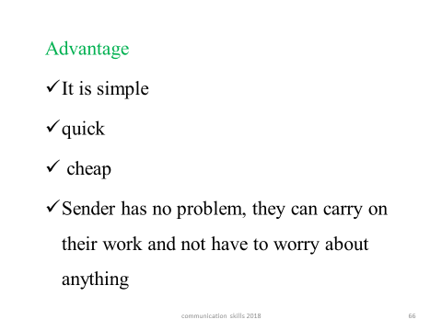

**Disadvantages**

* It allows no clarification or opportunity to correct inaccuracies and this may cause frustration in the receiver.
* It is often associated with authoritarian leadership and downward channels of communication.

**Two-way Communication**

* Two-way communication is more time-consuming because the receiver has the opportunity to feedback and to question what has been said or written.
* The receiver is invited to contribute to the process so this kind of communication is often associated with democratic forms of leadership.
* If the message is complex, two-way communication is far more effective, and probably accurate, than one-way communication.
* Two-way communication always includes feedback from the receiver to the sender and lets the sender know the message has been received accurately.

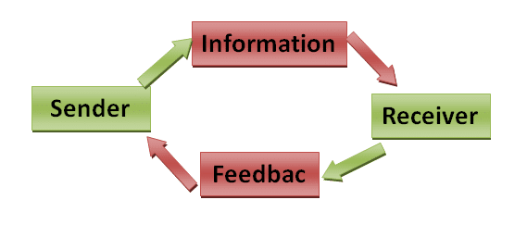

**Advantages**

* In two-way communication, communication is negotiated.
* Both sender and receiver listen to each other, gather information and are willing to make changes to work together in harmony.
* Their intent is to negotiate a mutually satisfactory situation.

**Disadvantages**

* The sender gets bothered and has to focus on what receiver wants more than what he or she wants
* Everyone has a different opinion and the sender has to work to make everyone happy

**Effective communication**

This is that communication which produces results. It is communication where the intended message is delivered clearly, and the desired feedback is achieved. It is communication that does not give room for misunderstanding. It is the best form of communication.

**Effective Communication Skills**

Effective Communication skills must include: communicating using

• Eye contact & visible mouth

• Body language

• Silence

• Checking for understanding

• Smiling face

• Summarizing what has been said

• Encouragement to continue

• Asking some questions

**Essentials and characteristics of effective communication**

**Essential of effective communication**

Qualities that ensure communication is effective. they have been summerised as 7C’s of communication.

1. Clarity – the need to use clear language such as familiar words, simple sentences and avoiding jargon’s. (clarity of expression and clarity of thought)
2. Completeness – giving all the details that are required in the communication situation; give all the facts, cover all the essentials and answer all the questions and is achieved through planning.
3. conciseness – use brief words or statements to communicating, include only necessarily materials and avoid unnecessary repetition.
4. Consistency – means all communication should be consistent in fact, treatment and sequence. has to do with orderly presentation and treating similar items in same way.
5. Correctness – always give accurate information interms of content and language mechanism. use of correct level of language, correct figures, gramma and acceptable writing mechanism.
6. Courtesy – refers to use of polite expressions that show respect use of non discriminating expression and being sincerely appreciation.

**Characteristics of Communication**

The characteristics of communication include:

* + Communication is a process: Communication is a 2 way process which involves; listening to others (Receiving) message Asserting/Expressing (Sending).
  + Communication is a dynamic: it is ever changing depending on the variables at play.
  + Communication is a complex a process.
  + Communication is a two-way process of reaching mutual understanding, in which participants not only exchange (encode-decode) information but also create and share meaning.
  + Communication involves the sharing of information using a code.
  + Communication occurs between people and sometimes animals
  + Communication is irreversible: once one has communicated something it cannot be recalled back.
  + Communication is a system
  + Communication must have the elements of communication: Source, receiver, channel, message, noise, feedback.
  + Communication can be verbal/ non verbal or visual.
  + Communication can be accidental especially in non-verbal

**How to be a good communicator**

To be a good communicator, one needs to:

* Express own reflections and ideas clearly
* Develop relationships
* Provide feedback (answers, reacts)
* Be open to others’ feedback (accept others answer without prejudice, references etc.
* Respect attitudes and opinions of others
* Be tolerant to different customs and cultures
* Give full attention to people while they are talking to you.
* Encourage other people to talk, and ask appropriate questions.
* Present your ideas so that others are receptive to your point of view.
* Treat people fairly and let others know how you want to be treated.
* Value teamwork and know how to build cooperation and commitment.
* Strive to understand other people and to be empathetic.
* Be able to easily win people’s trust and respect.
* Check to make sure you have understood what other people are trying to communicate.

**Advantages of Effective Communication**

1. Excellent communication skills prevents misunderstanding. It gives clarity and direction.
2. Effective communication skills provide clear and defined policies thus helps organization to be successful.
3. Effective interpersonal communication skills such as listening skills, making eye contact gives boost to your personality
4. If you are an effective communicator helps to make understand and understood things. It gives self-satisfaction
5. If you have good communication skills you are able to communicate a goal in an organisation. The people you communicate will perform their jobs more effectively.

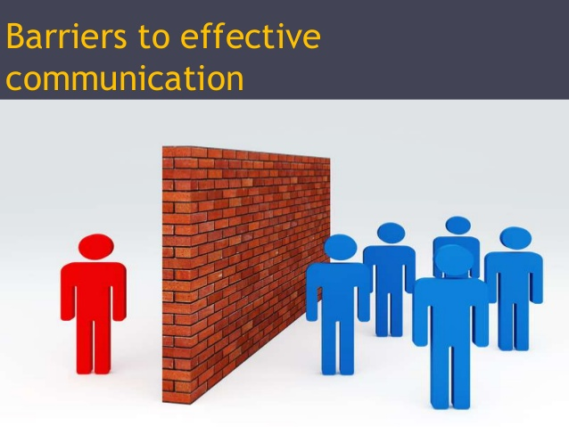

1. Semantic barriers
2. Organizational barriers
3. Psychological or emotional barriers
4. Personal barriers
5. Cultural barriers
6. Gender barriers
7. Perceptual barriers
8. Language Barriers
9. Environmental barriers
10. Physical Barriers
11. Physiological Barriers
12. **Physical Barriers:** It has to do with poor or outdated equipment used during communications, background noise, poor lighting, temperatures that are too hot or too cold.
13. **Emotional Barriers :** emotions like anger or sadness can taint objectivity.

Being extremely nervous, having a personal agenda or “needing to be right no matter what” can make communications less than effective.

1. **Language:**

Also people speaking the same language can have difficulty understanding each other if they are from different generations or from different regions of the same country.

Slang, professional jargon and regional colloquialisms can even hurt communicators with the best intentions.

1. **Physiological Barriers:** ill health, poor eyesight or hearing difficulties, pain.
2. **Organisational Barrier :** institutions can have organization structures that are not clear, which can make communications difficult.
3. Also to blame for faulty communications are bad information systems, and lack of supervision or training of the people involved.
4. **Cultural Noise:** people sometimes make stereotypical assumptions about others based on their cultural background.
5. **Semantic Barriers** refers to the misunderstanding between the sender and receiver arising due to the different meanings of words, and other symbols used in the communication.

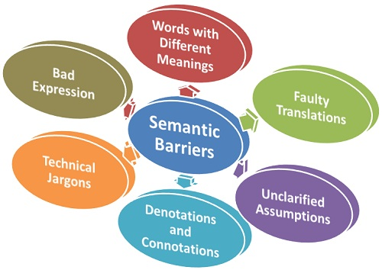

**Modes of communication**

**Intrapersonal communication**

Can be defined as communication with one’s self

It may include:

1. self-talk
2. acts of imagination
3. visualization,
4. even recall and memory

Example 1

* You read on your cell phone screen that your friends are going to have dinner at your favourite restaurant. What comes to mind? Sights, sounds, and scents? Something special that happened the last time you were there? Do you contemplate joining them? Until the moment when you hit the “send” button, you are communicating with yourself.

During intrapersonal communication all the interaction of the basic component of communication process occurs within the individual

* i.e., source, receiver, message, channel, feedback, environment, context, and noise

*Perhaps, as you consider whether to leave your location & join your friends (restaurant), you are aware of all the work that sits in front of you.*

*You may hear the voice of your boss, admonishing you about responsibility and duty*

*On the other hand, you may imagine the friends at the restaurant saying something to the effect of “you deserve some time off!”*

From the illustration, from planning to problem solving, internal conflict resolution, evaluations & judgments of self and others, we communicate with ourselves through intrapersonal communication.

All this interaction takes place in the mind without externalization, and all of it relies on previous interaction with the external world.

***Exercise***

Take a few minutes and visualize what you would like your life to be like a year from now, or five years from now. Do you think this visualization exercise will influence your actions and decisions in the future? Compare your thoughts with those of your classmates.

There are three major types of Intrapersonal Communication.

**1. Self-awareness**

* It is very important to understand how you see yourself about others. This intrapersonal communication determines your beliefs, ideas, values and attitudes. Your attitude is connected to the values you own. And values are based on your core beliefs.

**2. Perception**

* The perception aspect makes you stand out from others. How you see others and how you perceive others is filtered by your self-concept. We judge ourselves and other people so easily, that’s how we do intrapersonal communication. You are supposed to make your own rules and accept yourself with blind eyes. One need not be biased but need to take care of their own identities.

**3. Expectations**

* This is one of the most important intrapersonal communication. We always expect something in our future and also about others’ future too. Some people expect something big in life and keep working hard for the expectations to become reality. Sometimes we expect too much and then it leads to disappointments.
* These three aspects form a framework to channelize your thinking ability to deep dive into your within the self as well as your own rules for how to process things.

**Advantages of Intrapersonal Communication**

There are so many benefits of being a pro at Intrapersonal communication. In easy words, it is really good to be an intrapersonal person. It leads to so many openings of good possibilities. The advantages of Intrapersonal Communication are:-

* Help people understand themselves and their emotions. When you talk to yourself you understand yourselves better. It is very important to understand your emotional state. It determines everything for you.
* Helps you to grasp and understand the situations of others. We sometimes try to keep ourselves in the shoes of others to feel what they feel. This is also a part of Intrapersonal Communication.
* If someone is very much into Intrapersonal Communication, then it helps people to tackle many situations in mind. Analyzing problems becomes easy.
* The process of decision making enhances and problem-solving enhances with intrapersonal communication

**Forms of intrapersonal communication**

There are three major forms of Intrapersonal Communication

**1. Thinking**

This process includes thinking and day-dreaming. At the time when you think about something like how you behaved with your wife last night, or how you will ensure competitive advantage for your business, you are involving with your inner core via intrapersonal communication. We tend to think all the time and mainly when we concentrate or contemplate.

**2. Vocal**

This process includes talking to oneself out loud. This comes into play for replaying or rehearsing any message. You also do this to hear your own emotions or give yourself instructions. This form of communication is associated with self-talk. It is also an interpersonal skill, but then you talk to another person.

**3. Written**

This process includes all kinds of writings you do for your reading. It can be any personal diary, journal, reminders, shopping list, or notes. The written form of intrapersonal communication takes place in the process of being more organized and productive.

**Interpersonal Mode**

* Two-way communication between individuals using receptive skills (listening and reading) and productive skills (speaking and writing).
* The Interpersonal Mode is characterized by active negotiation of meaning among individuals.
* Participants observe and monitor one another to see how their meaning and intentions are being communicated.
* Adjustments and clarifications can be made accordingly.
* As a result, there is a higher probability of achieving the goal of successful communication in this mode than in the other two modes.
* The interpersonal mode is most obvious in conversation

However, both the interpersonal & negotiated dimensions can be realized through reading & writing, such as the exchange of personal letters or of electronic mail (e-mail) messages

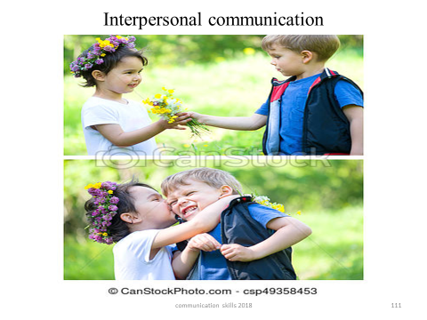

assignment: advantages and disadvantages of intrapersonal and interpersonal communication

**Difference between intrapersonal and interpersonal communication**

|  | **Intrapersonal Communication** | **Interpersonal Communication** |
| --- | --- | --- |
| Who is involved | Just you. | Two or more people |
| When it occurs | When you want to talk to yourself make a plan or introspect. | When you communicate with others. |
| Media | Mind, audio recordings, diaries, etc. | Phone, PC, TV, in-persons, letters, etc. |
| Associated with | Analysis, awareness, thoughts, etc. | Exchange of thoughts and ideas. |

**Mass Communication**

* It is a process of transmitting message to a large number of scattered audiences.
* Through mass communication, information can be transmitted quickly to a large number of people who generally stay far away from the sources of information.
* Mass communication is done through radio, television, newspaper, magazine, leaflets etc.
* Therefore, Mass communication is a process of sending a message, thought and attitude through some media at a time to a large number of heterogeneous audiences

Mass communication must contains at least following five things:

* + Large audience
  + Similar audience exists
  + Some form of message reproduction
  + Quick distribution of message
  + Low unit cost to the customers.
  + The Flow of Mass Communication

advantages/disadvantages of mass communication

**Advantages**

1. Information can be passed to many people at the same time
2. It is more likely to be transparent
3. It is both audio and visual e.g. TV

**Disadvantages**

1. Can lead to wrong perceptions
2. Can cause political or civil arrest
3. It is targets to a large number of people who may receive the message in different ways with different meanings
4. Mass media may not be reliable information because some newspapers manipulate the information in some cases to make news.
5. It is expensive e.g. purchasing newspapers everyday

**Kind of communication**

**Verbal Communication**

* Verbal communication can also be called as Oral communication.
* In very simple terms, any communication that happens orally between people is known as verbal communication.
* The objective of such communications is to ensure that people understand whatever you want to convey.
* Because of its very nature, verbal communications is more quick and precise then email communication
* Normally, a verbal communication takes place in real time.
* In the era of messaging people still prefer personal meetings or phone calls ([skype](https://www.marketing91.com/marketing-mix-skype/) calls) because they are effective and convenient
* The higher up an organization you go, the better should be the verbal skills that you have.
* It is because you need to ensure speech is precise and does not leave any scope for any misunderstanding.
* An M.D may be giving a television interview which is being watched by stakeholders
* Their speech and verbal communication need to be precise so that they are not misunderstood.
* Even in tough times, the verbal communication skills of these leaders play a major part in consoling the crowd.

**Examples/types/ forms of oral communications.**

**Unplanned exchange**

* This is communication that happens when a group of people meet and exchange words about a matter of common interest.

**Advantages**

* It is quick therefore urgent information may be give conveniently.
* It allows for free flow of thoughts as it reduces tension between the communicating parties

**Disadvantages**

* Easy to leave out important information
* It is common source of rumours
* Not easy to record therefore it lacks future references

**Planned exchange**

* It may take the form of unplanned informal talk.
* It offers a relaxed atmosphere for communication and may be sometimes be used in place of telephone calls.
* It is commonly used when reporting the progress of ongoing project.

**Interviews**

* Is a formal exchange between two people or between one person and small groups.
* Interviews take place for various reason such as job, school, appraisal and disciplinary interviews

**Advantage**

* Effect in gathering information since all concern parties are present. If carefully prepared they are effective therefore allowing an exchange of ideals which enable the parties to reach conclusion.

**Disadvantages**

* Takes up a lot of time
* May not allow for recording therefore leaving no reference for future

**Telephone**

* This exchange of information by use of telephone.

***Advantages***

* They are fast therefore allowing for urgent information to be released quickly.
* They are also convenient as information can pass from one person to another at any time.

***Disadvantages***

* They are expensive especially if international call are made. If conference call are made the cost of communication is also increased.
* Are prone to noise caused by poor connections, poor timing etc.

**Group meetings**

These are carried out by people with common interest.

They allow for sharing of skills and experiences and therefore lead to an agreeable conclusion.

***Advantage***

* Allow for equal opportunity for member’s presence to give their views

***Disadvantages***

* Are time consuming especially when participant has to travel to attend the meeting.
* Poorly planned they may lead to conflict and therefore create damage relationship betweenindividual or groups.

**Committee meeting**

* Is a special kind of group meeting where by a few individual are chosen to represent the larger group.

***Advantages***

* Proceedings of the meeting are recorded and may be used as a reference in future meeting (minutes or reports)

***Disadvantage***

* Agreement may be delayed since members have may have wide range of views.

Read on: - full staff meeting, Formal presentations

**Merits of oral communication**

* Allows personal contact therefore giving the message personal touch
* It may be supported by other method of communication such as a graphic and written communication therefore is better understood.
* It avails immediate feedback since the conveinor can interpret the expression of the audience and the audience can interpret the impact of the message from the tone of the conveinor.
* Allow sharing of ideals since sender and the receiver are presence.
* It is a fast method of communication especially where there all the parties are present

**Demerits of oral communication**

* Poor planning may lead to poor communication such as prolonged meeting which may interfere with the concentration of the parties concern and important point may be forgotten.
* Oral communication may lead to difficult in reaching conclusion especially if a large audience is let to express their opinions.
* It is time consuming where travelling arrangement have to be made to attend the meetings.
* It offers no future references if the proceeding are not recorded

**Written communication**

* In contrast to verbal communications, written business communications are *printed messages*.
* Examples of written communications include memos, proposals, e-mails, letters, training manuals, and operating policies.
* They may be printed on paper, handwritten, or appear on the screen.

**Informal notes**

* Takes the simplest form of writing as they have no specification of their format.

***Advantages***

* They are fast and may be used to give or relay urgent information
* They require no expertizes as anybody can write.

***Disadvantages***

* Allowing for errors therefore information is easily distorted.
* Sometimes parts of information may be omitted making it difficult to understand.
* Not applicable for relaying complex information.
* Not necessarily have an extra copy left or kept for future reference

**Memos**

It is more formal notes sent between members of the same organisation. It may be sent by members of different rank to communicate information ideals.

***Advantages***

Copies of memos may be retained for reference

They are short therefore less time consuming

***Disadvantage***

* Since they are short and concise they do not allow for detailed information to be passed.
* Compared to the telephone calls, they are not enough to relay urgent information.
* Long memos are off putting the leader.
* If not marked confidential information may be passed to wrong person

**Letters**

They are effective ways of passing various length of information.

***Advantages***

* They allow for all important details to be communicated.
* Copies may be retained for future reference.
* Individualized letters may be used for confidential information.

***Disadvantage***

* Not fast to relay urgent information
* They do not allow for immediate feedback
* Sometimes letters may be lost during potage especially when wrong address is used.

**Forms**

Used to gather the great deal of information quickly and in manner which is easy to read and interpret.

It may be used to crame from employment or apply for job

***Advantage***

If well designed they are easy to fill and maybe used as a quick way to gather information

***Disadvantage***

Are prone to error if not understood well by the leader.

Not all forms that may be return to the inquiring person

***Group discussion***

*Press release*

*Circular letter*

*Notices*

*Reports*

*Electronic means*

**Merits of written communication**

* Written materials may be used for reference in future in similar situation
* It is carefully planned therefore reducing change of error
* Information included is reliable since research may be done before document is prepared
* It may form a quick means of communication where it is difficult to have all the parties presence to be involved in a discussion or meeting.

**Demerit of written communication**

* As written word provides a permanent word it cannot be uttered or modified incase mistakes are made.
* Requires a highly skilled communicator change opinions or ideals of others by written response
* The communication may seem formal lacking a person touch.
* It may show lack of courtesy especially where a letter takes the place of a personal visit.

**NON-VERBAL COMMUNICATION**

**Non-verbal communication**

* What you say is a vital part of any communication.
* But what you *don’t say* can be even more important
* Research also shows that 55% of in-person communication comes from nonverbal cues like facial expressions, body stance, and tone of voice
* According to one study, only 7% of a Receiver’s comprehension of a Message is based on the Sender’s actual words; 38% is based on paralanguage (the tone, pace, and volume of speech), and 55% is based on *nonverbal cues* (body language) (Mehrabian, 1981).
* Research shows that nonverbal cues can also affect whether you get a job offer.
* Judges examining videotapes of actual applicants were able to assess the social skills of job candidates with the sound turned off.
* They watched the rate of gesturing, time spent talking, &formality of dress to determine which candidates would be the most successful
* For this reason, it is important to consider how we appear in business as well as what we say.
* The muscles of our faces convey our emotions.
* We can send a silent message without saying a word.
* change in expression can change emotional state.
* Before an interview, for example, if we focus on feeling confident, our face will convey that confidence to an interviewer.
* Adopting a smile (even if we’re feeling stressed) can reduce the body’s stress levels.
* To be effective communicators, we need to align our body language, appearance, and tone with the words we’re trying to convey.

**TYPES OF NONVERBAL COMMUNICATION**

1. Kinesics - Body Movements Gestures and Body Stance Facial Expressions Eyes Movements
2. Proxemics
3. Haptics
4. Chronemics
5. Paralanguage
6. Appearance
7. Artifacts
8. Environment

**KINESICS: (study of the way in which certain body movements and gestures serve asform of nvc.)**

* 1. **Body language** is a type of a nonverbal communication in which physical behaviors are used to express or convey the information. Such behavior includes facial expressions, body posture, gestures, eye movement, touch and the use of space. Interpretations of human body language. It is also known as kinesics.
  2. **Facial expression** is a part of body language and the expression of emotions such as the movement of the eyes, eyebrows, lips, nose and cheeks. The face displays numerous emotions such as: Happiness, Surprise, Disgust, Anger, Sadness, etc...
  3. **Head and neck signals**: The body language of the head should be considered in conjunction with that of the neck. Body language conveyed by the head and neck involves various ranges of movement. Nodding of the head is generally considered as a sign of saying 'yes'. Shaking the head is usually interpreted as meaning 'no'.
  4. **Body postures:** Emotions can also be detected through body postures. For example, a person feeling angry would portray dominance over the other, and their posture would display approach tendencies. Sitting or standing postures also indicate one's emotions. A person sitting till the back of their chair, leans forward with their head nodding along with the discussion implies that they are open, relaxed and generally ready to listen. On the other hand, a person who has their legs and arms crossed with the foot kicking slightly implies that they are feeling impatient and emotionally detached from the discussion
  5. **Gestures** - Gestures are movements made with body parts (example hands, arms, fingers, head, legs) and they may be voluntary or involuntary. Different hand gestures help emphasize meanings and regulate interaction between or among participants. For Example: Relaxed hands indicate confidence and self-assurance, while clenched hands may be interpreted as signs of stress or anger. If a person is wringing their hands, this demonstrates nervousness and anxiety.

* 1. **Oculesics** – Oculesics is the study of eye movement, eye behavior, gaze, and eye-related nonverbal communication. Eyes are said to be the window to the soul. - Through eye contact, one can tell if the other party is paying attention to the speaker’s words. - It can also help in determining whether one is saying the truth or not. - Through eye contact we can be able to know one’s emotional condition.

2. **PROXEMICS**

Another notable area in the nonverbal world of body language is that of spatial relationships, which is also known as Proxemics. Introduced by Edward T. Hall in 1966, Proxemics is the study of measurable distances between people as they interact with one another. Hall also came up with four distinct zones in which most men operate:

* Intimate distance for embracing, touching or whispering
* Personal distance for interactions among good friends or family members
* Social distance for interactions among acquaintances
* Public Distance used for public speaking.

1. **HAPTICS(Touch)-** It is the study of touching as such, handshakes, holding hands, back slapping, high fives, brushing up against someone or patting someone all have meaning. Touching is the most developed sense at birth and formulates our initial views of the world. Touching can be used to sooth, for amusement during play, to flirt, to express power and maintain bonds between people, such as with baby and mother.
2. **CHRONEMICS(Time)–** The use of time in nonverbal communication is formally defined as chronemics. Time perceptions include punctuality, willingness to wait, and interactions. The use of time can affect lifestyles, daily agendas, speed of speech, movements and how long people are willing to listen.
3. **PARALANGUAGE**– The attributes of voice like audibility, pleasantness, distinctness, and correctness in pronunciation, flexibility, etc. help to shape the meaning in oral communication. - These attributes help in creating meaning. - Paralanguage goes beyond the linguistic form of an utterance. Diction, the highness and lowness of tone, intensity, the manner of delivery, rate of speaking, etc. create the intended meaning of an utterance. - When something is delivered coupled with gestures and facial expressions may reflect the feeling(s) and/or emotion(s) of the participant in a communicative situation.

1. **APPEARANCE** Personal appearance refers to the way the audiences with their expectations of appropriateness, see and evaluate the way you look. The ways you look is all about your outward appearance of clothing, grooming, and make-ups. Physical appearance largely determines attractiveness and those who are attractive are more likely to be considered as more intelligent, more persuasive, and more likeable than the unattractive ones. Appearances also include: *Hairstyles * Body cleanliness * Clean Nails * Shiny shoes *No tattoos *Being appropriately dressed
2. **ARTIFACTS** Artifacts are forms of decorative ornamentation that are chosen to represent self concept. They can include rings and tattoos, but may also include brand names and logos. From clothes to cars, watches, briefcases, purses, and even eyeglasses, what we choose to surround ourselves with communicates something about our sense of self. They may project gender, role or position, class or status, personality, and group membership or affiliation.

1. **ENVIRONMENT** Environment involves the physical and psychological aspects of the communication context. The perception of one’s environment influences one’s reaction to it. For example, Google is famous for its work environment, with spaces created for physical activity and even in-house food service around the clock. The expense is no doubt considerable, but Google’s actions speak volumes. The results produced in the environment, designed to facilitate creativity, interaction, and collaboration, are worth the effort

[Elements of Non-Verbal Communication](http://blog.onrota.com/7-elements-of-non-verbal-communication/)

**“It’s not what you say, it’s how you say it”**

* This saying is given new meaning when you think about it in terms of body language.
* In addition to words spoken, you need to be aware of seven key things that convey messages.

1. **Facial Expressions.**

* Facial expressions are universal across all cultures and nationalities.
* They express emotions: happiness, sadness, anger, surprise, fear &disgust to name a few.
* You do not have to understand the verbal language to understand the non-verbal expressions.

1. **Body Movements and Posture**

* Your stance, posture, the way you walk, even subtleties such as the way you hold your head all convey an unspoken message.

1. **Gestures**

* We wave, point, beckon, and use our hands when we are arguing or speaking animatedly
* we express ourselves with gestures often without thinking.
* However, the meaning of gestures can be very different across cultures and regions
* so it is important to be careful to avoid misinterpretation.

**4)Eye Contact.**

* Eye contact is an important form of nonverbal communication.
* The way you look at someone communicates interest, affection, hostility, or attraction.
* Eye contact is also important in maintaining the flow of conversation and for gauging the other person’s response.

**5)Touch.**

* Touch is another important part of nonverbal com.
* Think about what the following conveys:
  + a firm handshake
  + a timid tap on the shoulder
  + a warm bear hug,
  + a reassuring pat on the back
  + a patronizing pat on the head
  + a controlling grip on your arm.

**6) Space.**

* We all have a need for physical space
* That need differs depending on the culture, the situation, and the closeness of the relationship.
* You can use physical space to communicate many different nonverbal messages, including signals of intimacy, aggression, dominance, or affection.

**7) Voice.**

* Nonverbal speech such as tone, pitch, volume, inflection, rhythm, and rate are important communication elements.
* When we speak, other people “read” our voices in addition to listening to our words.
* These nonverbal speech sounds provide subtle but powerful clues into our true feelings and what we really mean.
* Think about how tone of voice, for example, can indicate sarcasm, anger, affection, or confidence.

**Summary**

* Successful nonverbal communication depends on self-awareness & an understanding of the cues you are sending and reading the cues others are sending
* If you are planning what you are going to say next, daydreaming, or thinking about something else, you may miss nonverbal cues & other subtleties
* You need to stay focused on the moment to fully understand what is going on.

**Importance of non-verbal communications**

* Important in expressing our emotions
* Communicating interpersonal relationships
* Reflects individual’s personality.
* non-verbal communication is main supporter of verbal interaction. In fact they supplement each other and give full meaning.
* Plays greater role in performing rituals such as greetings and goodbyes.

**Interviews**

* It is a face-to-face interaction between interviewee and interviewer
* If handled carefully, it can be a powerful technique in having accurate information
* At the same time, if the interview is not handled carefully, it can be a source of bias, restricting or distorting the flow of communication.

Objectives of interview

* Verify the information
* Obtain additional information
* Gives the candidate necessary facts & information
* Establish mutual understanding

**Public Speaking**

* It's a presentation given live before an audience.
* Public speeches cover a wide variety of different topics
* The goal is to educate, entertain, influence listeners
* Often, visual aids such as slideshow are used to supplement the speech and make it interesting
* A public speaking presentation is different from an online presentation
* online presentation may be viewed and/or listened to at the viewer's convenience, while a public speech is limited to a specific time or place.

**Benefits of public speaking**

* Improves confidence
* Better research skills
* Stronger deductive skills (abilities that helps to use reason and logic to come to conclusions, validate information and make informed decisions about situations)
* Ability to advocate for causes

**How to become better at public speaking**

* Public speaking is a skill & it can be learned.
* While some people may have more natural speaking ability than others, or a more pleasing voice, or are more charismatic—anyone who can speak can learn to be a better public speaker than they are right now.
* It just takes some know-how and some effort.
* To help you become better at public speaking, we'll take a look at these four areas:
  + 1. Writing the speech
    2. Overcoming a fear of speaking
    3. Practicing the speech
    4. Giving the speech

**1. Write an Effective Speech**

* The first thing you'll want to do is work on writing a well-organized, engaging speech.
* Because even if you've got a great speaking voice or a great deal of charisma, you won't give a good speech if your material isn't any good.

**2. Overcome the Fear of Speaking**

* Fear of public speaking is very real and can hold you back.
* If you don't feel confident when giving your speech, your listeners may pick up on that, making your presentation less effective.
* Fortunately, there are some techniques that'll help most people manage their fear

**3. Practice the Speech**

* Even if not afraid of public speaking, practicing speech is still an important step to having an effective speech.
* If you're in a rush, you may be tempted to skip practicing your speech to save time.
* While skipping practice may seem like a good idea, it's really not.
* By practicing speech not only does it improve public speaking skills, but it also increases familiarity with the presentation
* Thus making it more likely that your speech will go smoothly.
* Watch recordings of your speeches

**4. Give the Speech**

* Engage with your audience
* Pay attention to body language
* Think positively

**LISTENING SKILLS**

* Listening is the ability to accurately receive and interpret messages in the communication process.
* Listening is key to effective communication.
* Without the ability to listen effectively, messages are easily misunderstood

As a result, communication breaks down and the sender of the message can easily become frustrated or irritated.

* If there is one communication skill you should aim to master, then listening is it.
* Good listening skills can lead to
* better customer satisfaction
* greater productivity with fewer mistakes

increased sharing of information that in turn can lead to more creative and innovative work

**Benefit in our personal life**

* A greater number of friends and social networks
* Improved self-esteem and confidence
* Higher grades at school and in academic work
* Better health and general well-being.
* Studies have shown that, whereas speaking raises blood pressure, attentive listening can bring it down.

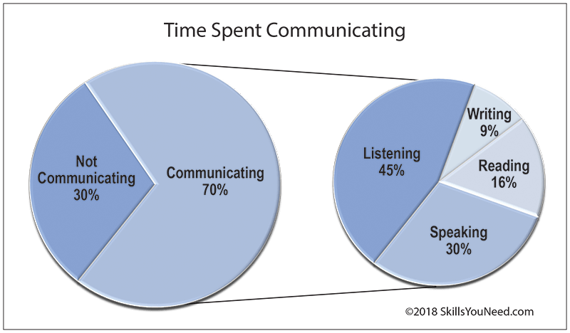

* Adults spend an average of 70% of their time engaged in some sort of communication.
* Of this, (45%) is spent listening compared to 30% speaking, 16% reading and 9% writing (Adler, R. et al. 2001).
* That is, by any standards, a lot of time listening.
* It is worthwhile, therefore, taking a bit of extra time to ensure that you listen effectively.

**Purpose of listening**

* To gain a full and accurate understanding into the speakers point of view and ideas.
* To critically assess what is being said.
* To observe the [**non-verbal signals**](https://www.skillsyouneed.com/ips/nonverbal-communication.html) accompanying what is being said to enhance understanding.
* To focus on the messages being communicated, avoiding distractions and preconceptions
* To show interest, concern and concentration.
* To encourage the speaker to communicate fully, openly and honestly.
* To develop an selflessness approach, putting the speaker first.

**Stages/steps/ process of listening**

**Receiving**

* Is the intentional focus on hearing a speaker’s message.
* This stage is represented by the ear because it is the primary tool involved with this stage of the listening process.

**Understanding**

* In the understanding stage, we attempt to learn the meaning of the message, which is not always easy.
* Deciding what the message means to you

**Remembering**

* Remembering begins with listening; if you can’t remember something that was said, you might not have been listening effectively.
* However, even when you are listening attentively, some messages are more difficult than others to understand and remember. Highly complex messages that are filled with detail call for highly developed listening skills.

**Evaluating**

* The fourth stage in the listening process is evaluating.
* Evaluations of the same message can vary widely from one listener to another.
* The stages two, three, and four are represented by the brain because it is the primary tool involved with these stages of the listening process.

**Responding**

* Responding—sometimes referred to as feedback—is the fifth and final stage of the listening process.
* Your reaction to the message. It can be emotional and intellectual
* For example, you are giving positive feedback to your instructor if at the end of class you stay behind to finish a sentence in your notes or approach the instructor to ask for clarification. The opposite kind of feedback is given by students who gather their belongings and rush out the door as soon as class is over.
* This stage is represented by the lips because we often give feedback in the form of verbal feedback; however, you can just as easily respond nonverbally.

**Importance of Listening**

**It’s important to listen because**

* Helps to show that we are serious
* Helps us to display respect to other’s view point
* Helps us to learn
* Helps us to adapt and understand
* Helps us to avoid communication errors.
* Helps to learn something new.
* It is essential skill for success in academics and business world.
* Helps to build and mantain relationships e.g. marriage
* helps us to determine whether people we are communicating with are honest or deceitful

**5 levels of listening:**

1. **Ignoring**  
   The lowest level of listening is called ignoring – not listening at all. If you are distracted by anything while talking to a user, they can get the impression that you are ignoring them. For example, while the user is speaking, you start a conversation or interject a comment with another IT support tech. You are ignoring your user.
2. **Pretend Listening**  
   Pretend listening is most easily explained in the face-to-face conversation. You’re talking to the other person and they have that “backpacking in Brazil” look in their eyes. On the phone it happens when you say things like “I see” and “OK,” etc. while working on an unrelated 1email or playing a computer game. People can tell you’re distracted.
3. **Selective Listening**  
   During selective listening we pay attention to the speaker as long as they are talking about things we like or agree with. If they move on to other things we slip down to pretend listening or ignore them altogether.
4. **Attentive Listening**  
   Attentive listening occurs when we carefully listen to the other person, but while they are speaking we are deciding whether we agree or disagree, determining whether they are right or wrong. Instead of paying close attention to the other person, we’re formulating our response to what he or she is saying. At all four of these levels it should be evident that we are listening to our own perspective, and in most cases with the intent to respond from our experience.
5. **Empathic Listening**/empathetic listening, - the top level of listening. To be successful in providing IT support to end-users, you must teach yourself to treat every call as though this is the first time you’ve ever heard this problem, even though you may have heard it many times before. Discipline yourself to see it through the eyes of the user. This is called empathic listening. Empathic listening is the highest level of listening, and the hardest to accomplish.

**Basic Types of Listening**

* Active listening
* Selective listening
* Emphatic listening
* Ignoring listening

**Barriers to effective listening**

**physical barriers**

* Consist of any sound that prevent a person from being heard. Physical noise interferes with a speakers ability to receive them e.g. whispers, cheers, passing cars.

**Physiological barrier**

* It arises when listener suffer from ill health, fatique, sleeplessness hearing problems
* It may also be due to the accent and pronunciation shortcomings of the speaker.

**Psychological barrier**

It covers the value system and the behavioral aspects.

Some examples where listening fails to be effective of account of people related factors are as follows

* The speaker speaks in a shrill voice that does not reach the receiver
* The speaker speaks very rapidly or with an accent that is not clear.
* The receiver of the message does not consider the speaker to be well informed

**OR**

However, some of these possible barriers to effective listening can be list as follows;

* sources of noise
* Forming a judgment or evaluation before we understand what is being said, or ‘jumping to conclusions’.
* Hearing what we want to hear.
* Tuning out a point of view that differs from our own.
* Formulating and rehearsing our response.
* Being inattentive - thinking about something else entirely.
* Having a closed mind- you do not want to hear what the person has to say.
* Feeling anxious or self-conscious.
* Judging the person, either positively or negatively.
* 10.Subjective biases based on ignorance or prejudice.
* Cultural issues, e.g. listening to the differences in pronunciation of different accent, rather than the content of the message.
* Excessive and incessant talking or interrupting.

It is important that such barriers to listening are recognized and dealt with. With developing awareness, we can have more control over those barriers that are internal to ourselves, and can adopt and use more helpful listening behaviors.

**Ways of improving listening skills**

Listening effectively is hearing and understanding what a speaker is saying and how it applies to you, and then remembering it for future use and evaluation. There are ways to improve your listening skills

* Always be prepared to listen psychologically and physically – this is getting into right mental attitude, gather as much information as you can about the topic your going to listen to and be ready to consciously mentain attention.
* Be interested – look interest and try to find some relevant in the message that is given.
* Keep and open mind – listen to event that contradict your believes, attitude and ideas. ignore speaker appearance and manners of presentation and listen to the message. do not jump to nasty conclusion.
* Learn to listen to main ideas which may be captured in the preview of summary. they may also be repeated oftenly during the deliverly of the message or may be marked by disclosure mark e.g. the first import point is……..
* Listening carefully when you analyse the speaker message in order to make a critical judge about the message.
* Identify all the possible barriers and eliminate them

**How To Listen Effectively?**

* Stop Talking – Be Silent
* Show Interest
* Empathize
* Ask Questions
* Maintain Eye Contact
* Take notes
* Listen Creatively
* Put Your Entirety
* Send feedback
* Avoid or eliminate distraction
* Try to gather information about the topic to develop interest and familiarity.

**Benefits of Effective Listening**

* Enhances productivity
* Improves relations
* Avoids conflicts
* Improves understanding
* Improves negotiation skills
* Adds to your Image & Personality

**PATTERN OF COMMUNICATION**

* Communication means transferring messages from one to another
* It is classified into verbal, non-verbal and written
* It has several forms such as intrapersonal, interpersonal, group and mass communication.
* When it comes to group communication it has a certain pattern in its own.

it shows how communication flows within a group

* In other words, communication ***Pattern are the communication links in work teams according to the organizational structures***.
* The patterns are related to **work efficiency** and **who is responsible towards whom** or who talks to whom.
* It also relates to satisfaction of group members and decision-making process.
* The communication patterns that have been given by Harold J. Leavitt for four-and-five member group are

1. Circle
2. Chain
3. Wheel
4. Y
5. Network
   1. Circle

* In circle communication pattern, there is a leader and hierarchies in the group members.
* He/she cannot talk with any other members too, like the lowest level of workers.
* All group members can communicate with the leader through the members who present above and below that person. The message flows in a single direction.
* It is not possible for the group members to communicate directly with the leader in circle communication pattern which is also a disadvantage of this pattern.
* They can only communicate with the leader through other group members senior to them

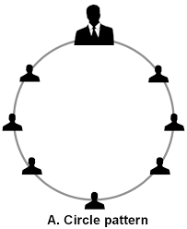

***Chain pattern* –** chain pattern appears like a circle pattern it also follows few chains of command. In this pattern last person receives the message from the leader. It is a one-way flow communication.

In chain communication all members did not get the opportunity to talk to the leader directly so they might receive modified lecture of the leader. There is no feedback to identify message distortion. A leader does not know whether last member receives the message or not.

***Y Pattern –*** the group is separated into three and the group members can communicate with the leader only. This pattern is little complicated as three different groups are situated into one single group. According to Levitt these three groups are controlled by a single leader. There are three members in each subgroup.

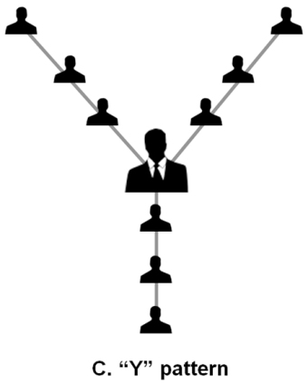

**Wheel**

* In wheel pattern, there is a leader at the centre of all communication.
* All others are members that stand at the same level in the structure.
* Here, all members can communicate with the leader and vice versa.
* But, members cannot interact with each other. Sometimes, members do not even know of the existence of other members of the same group.
* This pattern is taken as the best pattern of communication for any organization as a leader can have direct contact with all.

**Reading and writing skills**



Read and write notes on Network pattern

**DIRECTION OF COMMUNICATION**

* Directions of communication include
  + - 1. Vertical Communication
      2. Horizontal Communication
      3. Diagonal Communication
      4. Grapevine Communication
* While the first three channels of communication are formal ways, the last one is an informal way of communication.

**a)Vertical Communication**

* Vertical communication can be divided into two categories i.e. **upward communication** and **downward communication**.
* Downward communication refers to communication that flows from the superior authority to the subordinate authority or from the higher level to the lower level.
* It is the most important direction of comm. and the very nature of the organisation.
* No organisation can function without it.

Downward communication is mostly used give instructions - both written and spoken, letters, memorandum, policy matters, speeches, meeting, information etc

* Upward communication refers to communication that flows from the **subordinate** to the **superior** or from the lower level to the upper level.
* It is mainly used by employees to give **feedback** about various responsibilities also to give suggestion
* It includes reports, proposals, suggestions, grievances, etc

**b) Horizontal Communication**

* Takes place between two or more persons who are subordinates working in the same section or dept.
* It is a frequently used channels of communication to maintain coordination between people of the same level.
* In this process message flows **not only up and down** but also **sideways**.
* During such interactions the views of each other are made known & decisions are arrived quickly.
* Here there is no superior or subordinate relationship.

**c) Diagonal Communication**

* It includes the **horizontal flow** of information as well as **interaction across different levels** of an organisation's hierarchy.
* Diagonal communication is used to speed up the flow of communication.
* It makes effective efforts for achieving organisational goals.

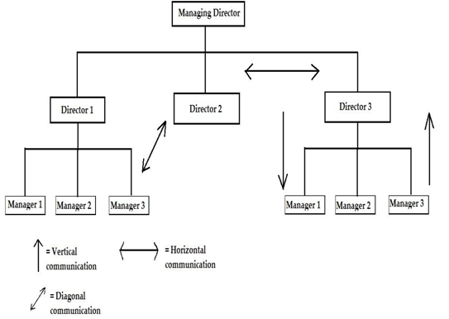

**d) Grapevine Communication**

* It is a type of informal business communications which develops within an organisation.
* It means gossip.
* Usually gossip that spreads and covers a lot of ground (a lot of people) like vines do.
* However, there are disadvantages or limitations to grapevine communication.
* It has the potential to spread unnecessary gossips.
* It can be dangerous to the organisation if allowed to grow without monitoring.
* It may result in character assassination and personal vilification of individuals.
* It may provoke sudden unwanted and unexpected reactions from emotionally unstable people.
* Grapevine channel can be moderated but not eliminated.